Created by Emma MacKay, Year 3 Medical student

This leaflet has been designed to inform our patients on the best ways to stay safe and healthy when travelling. If you have any questions or need further advice, please contact the practice and schedule an appointment with your GP.

FOOD & WATER SAFETY

WATER

There are many illnesses which can be caught by ingesting unsafe water, for example when brushing your teeth or swimming in a pool which isn’t correctly treated with chemicals. Websites such as NHS Fit For Travel are useful to check the water quality in the place(s) you are visiting, as tap water in some countries is not safe for consumption.

Illness can be prevented by only using bottled water. If this is not possible, water should be purified using one of the following methods:
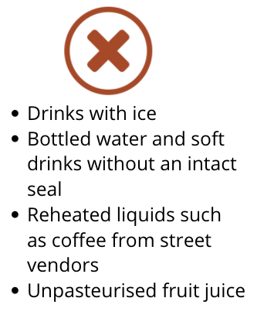
- Boiling water for at least 1 minute- longer in higher altitudes
- Water purification tablets
- UV radiation devices

Water filtration alone is not effective at purifying water but can be used alongside one of the methods above (1). If you need water to make up formula feed for your baby, it is important that you check tap water safety and bring adequate sterilisation equipment. Bottled water is not usually sterile and still needs to be boiled prior to use if being used for a bottle feed (3).
Potential sources of contaminated water to avoid (2)

If you plan on swimming during your trip, you need to be cautious about the quality of water you are swimming in. Many dangerous infections can be caught while swimming, for example Schistosomiasis- a freshwater parasite which is endemic to South America, Asia, Africa, and the Caribbean. Avoid swimming in untreated water, especially after heavy rainfall, near storm drains or water which may contain animal waste (4).

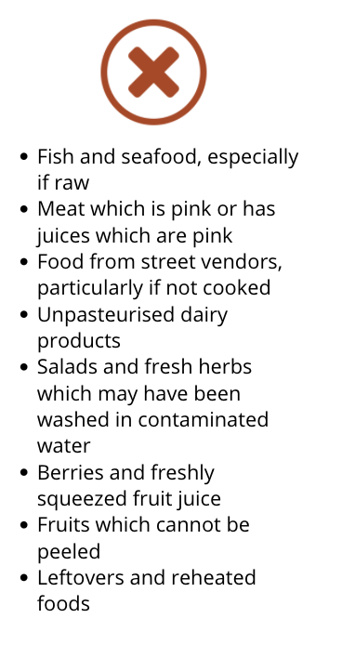
FOOD

Hand hygiene is important in preventing cross contamination of food and any harmful organisms. Hands should be washed thoroughly for at least 20 seconds using soap and water before and after eating and drinking, handling food, touching raw meat, and after using the toilet. If soap and water is not available, an alcohol-based sanitizer can be used (2).

Cooking food is one of the simplest and most effective ways of making sure food is safe to eat. Bacteria is killed at 70 ⁰C, hence food should be served straight away while it’s hot. Certain foods are particularly at risk and should be avoided (4).

TRAVELLER’S DIARRHOEA
Foods which are high risk of contamination and should be avoided (4)

Traveller’s diarrhoea (TD) is the most common illness which effects travellers. Symptoms include diarrhoea, usually within the 1st week of travel, a fever, nausea, and vomiting. There are no vaccines which can prevent TD, however hand hygiene and following food and water precautions are the best preventative measures. High risk areas for TD include South and Central America, Africa, Southeast Asia, and the Middle East.

Most cases of TD resolve themselves within a few days. The main danger of TD is dehydration, which can be treated with rehydration salts such as Dioralyte that can be bought over the counter at pharmacies. Anti-diarrhoeal tablets should never be used in children under 4 and require a prescription for children under 12 (5).

Seek medical attention if:
- Symptoms do not improve within 3 days
- The diarrhoea is accompanied by a fever of 38⁰C or more, confusion or severe abdominal pain
- There is blood and/or mucous in the stool (6)

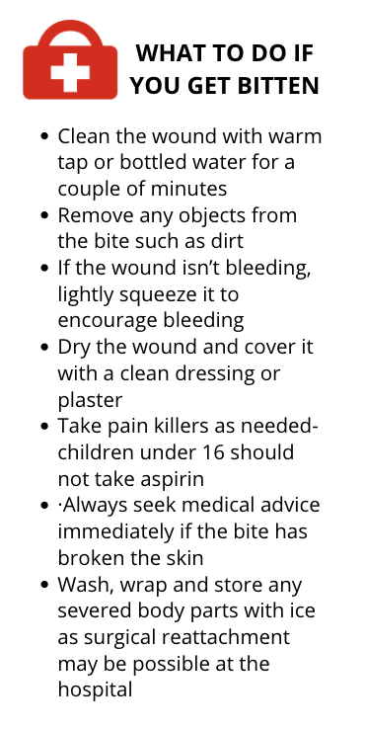
BITE AVOIDANCE

ANIMAL BITES

Animal bites are a common risk globally, especially when travelling with children who aren’t aware of the dangers of interacting with animals. While there is a risk in any country, animal associated injuries are most common in Thailand, Indonesia, and Nepal where there are a lot of stray animals. Animals carry bacteria in their mouths which can potentially lead to serious infections if not treated quickly (7).

It’s important to check the rabies status of the country you are travelling to, as there are vaccines available to prevent against infection. This can be done by checking the TravelHealthPro website, which has the most up to date statistics on rabies infections in each country (see Further Information) (9). Rabies vaccination courses take up to a month to complete, so it is important to schedule an appointment with a travel clinic well in advance of your trip (10).
Basic first aid for animal bites (8)

INSECT BITES

As well as causing discomfort, insect and tick bites can carry many different infections, such as malaria and Lyme disease. It is important when travelling to a country with a high prevalence of mosquitoes and ticks to follow advice on how to prevent getting bitten:
- Wearing long sleeved tops and trousers
- Light coloured clothing makes ticks more visible if bitten
- Insect repellents containing DEET are the most effective and should be applied to all exposed areas of skin after sunscreen. Concentrations applied to skin should not exceed 50%. Other suitable insect repellents include: icaridin and lemon eucalyptus.
- Using mosquito nets, preferably impregnated with an insect repellent- these are available to buy at travel clinics
- Check the skin for bites at the end of the day, particularly in the folds of the skin such as the armpits in an area with a lot of ticks (11)

If you are bitten by an insect, basic first aid is usually all that is required. Any stingers should be removed and cold compresses and/or painkillers can be used to reduce discomfort. Ticks must be removed properly with special tick removers or tweezers, as if the tick is not removed properly it can lead to infection (12).
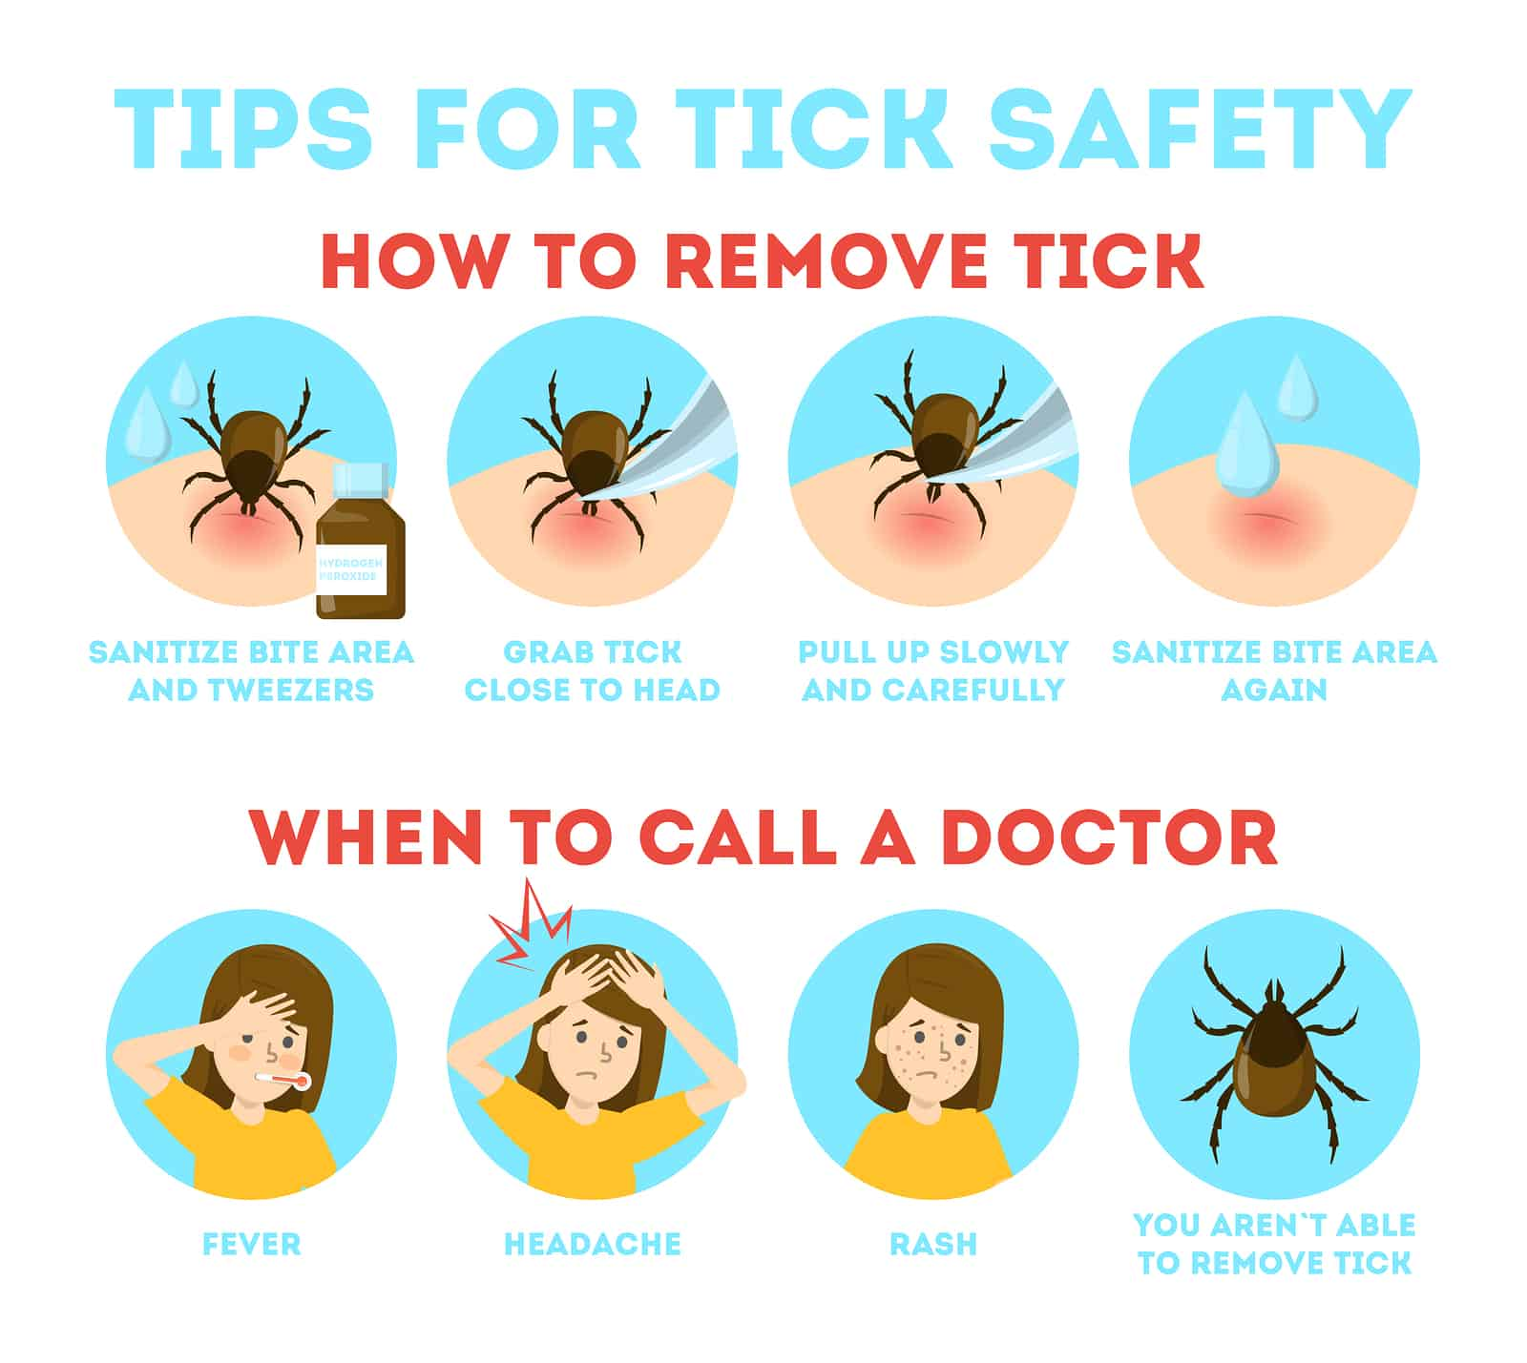

How to remove a tick safely (13)

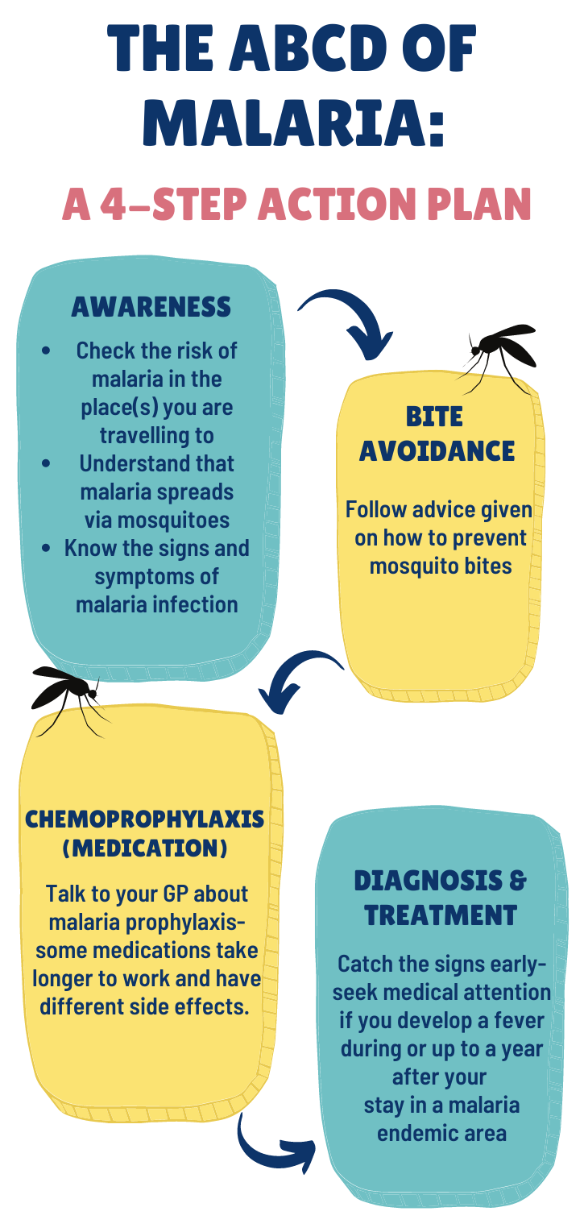
MALARIA
ABCD approach for malaria prevention (13)(14)

Malaria is a serious infection caused by a parasite which is spread through mosquito bites. Its prevalence is increasing worldwide and can vary between countries, regions, and seasons. It is important to check the risk of malaria in the place(s) you are travelling to at the time of year you are going.

There are no vaccinations against malaria, however the ABCD approach can be taken to protect yourself abroad. Certain people are more at risk of developing a serious infection if they catch malaria, and should organise to see a travel health professional in advance of their trip:
- Pregnant women
- Babies, children, and older people
- People with a compromised immune system or without a spleen
- People with certain pre-existing medical conditions

Antimalarial tablets are recommended if you are at risk of developing serious malaria infection or are travelling to a country where there is an outbreak or high risk of catching malaria. Some tablets need to be taken over a week in advance of your trip, so it is important to talk to a health professional about prophylaxis well in advance of travelling. Antimalarial tablets are not available on the NHS so will need to be purchased through a travel clinic. These tablets are not 100% effective; hence bite avoidance advice should be followed alongside them. (14)(15)

IMMUNISATIONS
There are vaccines available for some serious diseases which are prevalent in other parts of the world. If you are thinking about getting vaccinated, you should ideally make an appointment with a travel clinic ideally at least 8 weeks before your departure date to see which immunisations you may need (16).
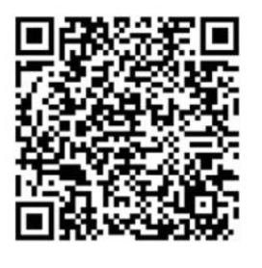
As of the 1st April 2022, GP practices no longer provide travel immunisations.
For further information, please scan the QR code provided or visit: https://www.nhsggc.scot/your-health/general-vaccinations/overseas-travel-vaccinations

You may not be allowed to enter certain countries without having the right immunisations. Yellow fever vaccination certificates (also referred to as an International Certificate of Vaccination or Prophylaxis/ICVP) are required or highly recommended for travel to most countries in South America and Africa. An up-to-date list of countries which require certification can be found on TravelHealthPro, and yellow fever vaccination centres are listed on the NHS Inform website (see Further Information) (17)(18).

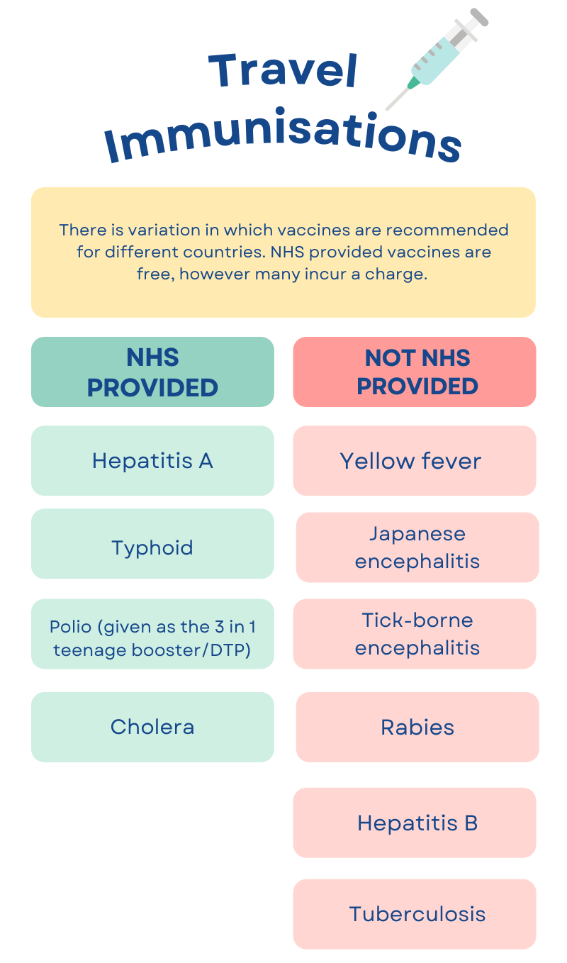

Summary of which travel immunisations are available on the NHS (19)

TRAVELLING WITH MEDICATION

If you are currently taking medication(s), it is important to check with your GP or practice nurse that it can be taken out of the UK and into the countries you are visiting, including any stopovers, at least 2 months in advance of travel. Limits imposed by different countries can differ depending on the type or quantity of medication. Countries such as Turkey, India, Pakistan, and the UAE are particularly strict on taking medication into the country. The lists of medications which are restricted in each country can be found on their embassy websites. A list of embassies can be found on the UK Government website (see Further Information).

When taking permitted medication overseas, it is important that you have an adequate supply for the duration of your trip and any unforeseen losses or delays. Carry your medication in hand luggage and try to keep it at the correct temperature, for example in an insulated pack. Any medication and medical equipment should be kept in its original packaging with labels intact. Prescribed medicines may require the prescription alongside them to prevent confiscation. Air travel restrictions on liquids are exempt for medication, however medical documentation such as a letter from your GP may be required (20)(21).

FURTHER INFORMATION

Below are some websites which have further information on travel advice. It may be helpful to look at the advice for each destination you are travelling to before making an appointment with a travel clinic.

RESOURCE | WEBSITE
TravelHealthPro: An A-Z list of countries and any relevant travel considerations | https://travelhealthpro.org.uk/countries
Foreign & Commonwealth office: advice for personal safety when travelling | https://www.gov.uk/foreign-travel-advice
NHS Fit For Travel website: updates on travel health advice and outbreaks, such as malaria maps and up to date vaccine information | https://www.fitfortravel.nhs.uk/destinations
List of embassies on UK Government website: important when travelling with medication | https://www.gov.uk/government/publications/foreign-embassies-in-the-uk
Brownlee Centre Travel Clinic | https://www.nhsggc.org.uk/your-health/health-services/brownlee-centre/brownlee-centre-travel-medicine/
List of English speaking doctors & medical facilities worldwide | https://www.gov.uk/government/collections/doctors-and-medical-facilities-worldwide-list
British Mountaineering Council: information for those planning on trekking / travelling to high altitudes | https://www.thebmc.co.uk/
IBD Passport: resources for patients travelling with IBD | https://Ibdpassport.com
Travelling with diabetes | https://www.diabetes.org.uk/guide-to-diabetes/life-with-diabetes/travel
British Skin Foundation: Sun safety | https://www.britishskinfoundation.org.uk/how-to-stay-safe-in-the-sun?gclid=EAIaIQobChMIubj32eaJ6wIVA

REFERENCES

- 1. Guidelines for drinking-water quality, 4th edition: 1st addendum [Internet]. Who.int. 2017 [cited 22 March 2022]. Available from: https://www.who.int/publications-detail-redirect/9789241550017
- Food and Water Precautions - Fit for Travel [Internet]. Fitfortravel.nhs.uk. [cited 22 March 2022]. Available from: https://www.fitfortravel.nhs.uk/advice/general-travel-health-advice/food-and-water-precautions
- Breastfeeding and bottle-feeding [Internet]. Travax. 2020 [cited 22 March 2022]. Available from: https://www.travax.nhs.uk/health-advice/special-groups/breastfeeding-and-bottle-feeding/
- Griffin P, Hill V. CDC Yellow Book: Food and Water Precautions [Internet]. 2019 [cited 22 March 2022]. Available from: https://wwwnc.cdc.gov/travel/yellowbook/2020/preparing-international-travelers/food-and-water-precautions
- Traveller's Diarrhoea [Internet]. Travax. 2021 [cited 22 March 2022]. Available from: https://www.travax.nhs.uk/health-advice/general-health-advice/travellers-diarrhoea/#prophylaxis
- NaTHNaC - Travellers’ diarrhoea [Internet]. TravelHealthPro. 2019 [cited 22 March 2022]. Available from: https://travelhealthpro.org.uk/factsheet/53/travellers-diarrhoea
- Animal Bites [Internet]. Fitfortravel.nhs.uk. [cited 23 March 2022]. Available from: https://www.fitfortravel.nhs.uk/advice/
- Animal and human bites [Internet]. Nhsinform.scot. 2020 [cited 23 March 2022]. Available from: https://www.nhsinform.scot/illnesses-and-conditions/injuries/skin-injuries/animal-and-human-bites
- NaTHNaC - Country List [Internet]. TravelHealthPro. [cited 23 March 2022]. Available from: https://travelhealthpro.org.uk/countries
- Rabies - Vaccination [Internet]. nhs.uk. 2020 [cited 23 March 2022]. Available from: https://www.nhs.uk/conditions/rabies/vaccination/
- Mosquito bite avoidance [Internet]. Travax. [cited 23 March 2022]. Available from: https://www.travax.nhs.uk/health-advice/general-health-advice/mosquito-bite-avoidance/
- Insect bite avoidance [Internet]. Travax. [cited 23 March 2022]. Available from: https://www.travax.nhs.uk/health-advice/general-health-advice/insect-bite-avoidance/
- Proper Tick Removal [Internet]. TickSafety.com. [cited 23 March 2022]. Available from: https://ticksafety.com/removal-prevention/proper-tick-removal/
- Bell D. Fever in the returning traveller. The Journal of the Royal College of Physicians of Edinburgh. 2012;42(1):43-46.
- Malaria: Awareness of risk [Internet]. Travax. [cited 24 March 2022]. Available from: https://www.travax.nhs.uk/malaria/awareness-of-risk/
- Travel vaccinations [Internet]. nhs.uk. 2018 [cited 24 March 2022]. Available from: https://www.nhs.uk/conditions/travel-vaccinations/
- NaTHNaC - Yellow fever: updated country certificate requirements, 2021 [Internet]. TravelHealthPro. [cited 24 March 2022]. Available from: https://travelhealthpro.org.uk/news/581/yellow-fever-updated-country-certificate-requirements-2021
- Yellow Fever Certificate Requirements [Internet]. Travax. 2020 [cited 24 March 2022]. Available from: https://www.travax.nhs.uk/destinations/asia-east/india/yellow-fever-certificate-requirements/
- Vaccine charges [Internet]. Travax. 2020 [cited 24 March 2022]. Available from: https://www.travax.nhs.uk/vaccination-practice/further-information/vaccine-charges/
- Travelling with Medication [Internet]. Travax. 2021 [cited 25 March 2022]. Available from: https://www.travax.nhs.uk/health-advice/general-health-advice/travelling-with-medication/
- Can I take my medicine abroad? [Internet]. nhs.uk. 2021 [cited 25 March 2022]. Available from: https://www.nhs.uk/common-health-questions/medicines/can-i-take-my-medicine-abroad/

